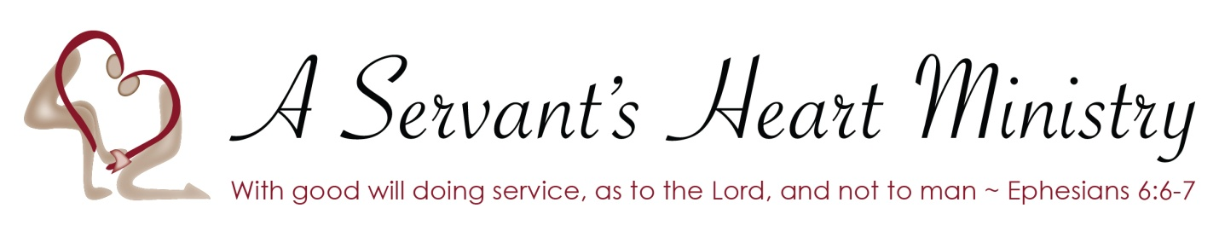

Rules and Expectations during my contract period with A Servant's Heart Ministry / Training program...
During the course of each contract each person will have an accountability log that will detail daily tracking of activities, services involved in, off site training classes also including signing in and out to understand and exercise the importance of being accountable.
The use of drugs, alcohol, nicotine,
( also including cigars, pipes and vaping) narcotics or any other kind of mind altering substance will NOT be permitted.
We have a zero tolerance policy that immediately terminates a contract if found in possession of, or under the influence of any listed item above. (All will be subject to random drug testing)
The language and character exampled will be without profanity and any other form of communication that brings rude, crude, hurtful or harmful speech, either directly or indirectly spoken to others or jesters that can be intimidating or considered threatening. All forms of these behaviors will be addressed and followed by consequences at the discretion and decision of the administrator.
When working off site the same standard of respect and integrity is expected to be given to ALL as if serving on site with A Servant's Heart Ministry.

By signing this form I acknowledge I have read and fully understand what behavior is expected of me and the consequences that will follow if not upheld on my part.

Applicant’s Signature. ______________________ Date ____________

