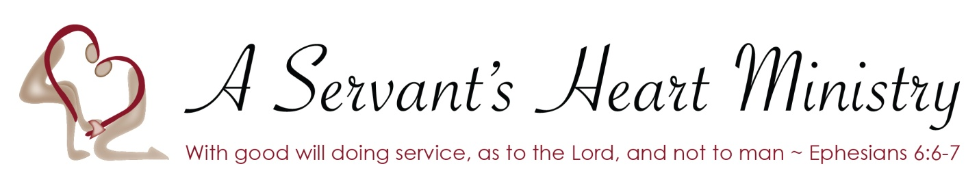

I ________________On this day _____________________ enter into this training contract with A Servant’s Heart Ministry. I understand the rules and standards of a Servant’s Heart Ministry that must be obeyed and exercised in my daily activities during my stay with A Servant’s Heart Ministry. This 30 day contract applies to a 30 day blackout period which restricts any outside contact such as phone calls, social media, onsite or offsite visits unless approved by the administrator in writing. I fully understand should I choose to break any rules onsite or off site, my stay at a Servant’s Heart ministry ends immediately and I am not entitled to receive a 30 day notice or formal eviction process. I fully understand any fees paid to date will Not be reimbursed.
During my stay and training with A Servant’s Heart ministry I understand I will be working and serving along side a diverse group of people and will respect all those I come in contact with and uphold the same standards of A Servant’s Heart Ministry.
I understand there is a zero-tolerance policy against the use of narcotics, alcohol, non-prescribed medications, vaping and nicotine or mind altering substances on site or offsite during my contract with A Servant’s Heart Ministries. I agree to random room and or personal possession searches at the discretion of staff or administrators.
I ______________________ agree to random drug testing and fully understand the consequences of failing a drug test. I understand if I have a medical condition that requires regular intake of medication there will be a plan of action and a schedule to monitor my doses, which has to be approved by the administrator and placed in my folder onsite.
By signing this contract, I acknowledge I have read and fully understand the rules and policies of A Servant’s Heart Ministries.
Applicant Signature _________________Date_____ Staff Signature_______________ Date_____

